**Question 1**

1. Explain briefly **how** does a computer **store data** in memory devices. (5 mark)

Computers store data in memory devices in different ways. Main memory (RAM and ROM) usually uses electronic technologies, while secondary storage uses mainly magnetic or optical technologies.

Data is stored in ROMs in the manufacturing (semiconductor-fabrication) process itself – by choosing to include or exclude transistors in a memory matrix. Variety of ROMs exist those allow you to programme after manufacturing (PROMs) usually by burning transistors within the chip via a special ROM programming device or EPROMs (Erasable-Programable ROMs) those allow reprogramming by storing or removing electric charges in transistors in the memory matrix.

RAMs operate mainly by keeping or discharging electric charges in transistors – mostly these transistors act as capacitors.

Magnetic memory usually magnetize each bit in the magnetic media (disks/tapes) one direction or its opposite direction.

In optical storage, bits are usually coded into pits and lands along a spiral track on an optical disk.

1. List down main **functionality** of following components of a personal computer (9 mark)
   1. Processor

Performs processing, consists of ALU, CU (Control Unit) and some registers to hold operands, instructions and other control data. The processor fetch the instruction pointed to by the PC/IC program/instruction counter into IR(Instruction register) and CU execute the instruction in IR by generates the required control signals to implement the instruction.

* 1. Main memory

Usually the volatile memory that holds the data (both input and output) and the programs the CPU executes.

* 1. Secondary memory

Non-volatile memory where data and programs are stored for long term operation of a computer.

1. Recognize the difference between system software and application software providing suitable examples. (4 mark)

System software includes the essential programs required by a computer to utilize it easily and efficiently – consists of OS and other utility programs.

Application software usually cater for the use needs. Application SW utilizes system SW to provide their functionality to the users. Eg – MS Office, custom made applications, LMS, Payroll, or inventory control SW.

1. Define the term “Clock Speed” (2 mark)

Every digital computer system need a clock to drive the system. Clock speed is usually given in Hz (GHz), meaning how many pulses in a second. Usually the clock is embedded in the motherboard chipset in a PC.

**Question 2**

1. Convert following numbers to octal equivalents

a) 4208 b) 51B16 (4 mark)

1. Perform following operations using 2’s Complement method (use 8 bits)

a) 3010 + (-2710) b) (-1610) - (+1210) (6 mark)

1. Convert -123. 62510 to its binary equivalent. Then represent it in IEEE 32 bit floating point representation (4 mark)
2. Represent -505, +138 in:
   * 1. Zoned Decimal Representation method.
     2. Packed Decimal Representation method.
     3. Binary coded Decimal Representation method (6 mark)

**Question 3**

1. Design **three** files giving File Names, Field Names, Field Types and Field Sizes and mentioning primary keys to store Account details, Account Type details, and Transaction details of a bank. Assume that each customer will have only one account. (4 mark)

* 1. If there are 100 000 Accounts, 20 different Account Types, and 1 000 000 transactions per day Calculate the total file size (3 mark)
  2. What is the total file size after 10 days (3 mark)

1. A disk file of 900,000 records is to be processed sequentially. The record size is 150 bytes and the sector size is 1024 bytes. The time taken to read a sector is 0.1 ms  
   and the time taken to process the records in a sector is 0 .3 ms.
   1. Calculate the number of records that can be stored in one sector (2 mark)
   2. Calculate the number of sectors required for the whole file (2 mark)
   3. Calculate the time taken to read and process all records in the file (2 mark)
2. A magnetic disk has 10 platters, 80,000 tracks on each surface and 400 sectors per track. The capacity of a sector is 2 KB. Compute the capacity of a Track, Surface, Cylinder and Disk

(4 mark)

**Question 4**

1. Develop an algorithm using pseudo codes that asks the user for a number n and prints the sum

of the multiples of three from 1 to n.

Define sum=0

Define m=3

Input n

While (m<n)

sum=sum + m

m=m+3

end While

Display sum

Eg: if n = 20 then the output should be 63 (as 3 + 6 + 9 + 12 + 15 + 18 = 63) (10 mark)

1. Draw a Flow Chart that asks the user for 2 numbers n and m and list down all prime numbers between n and m (10 mark)

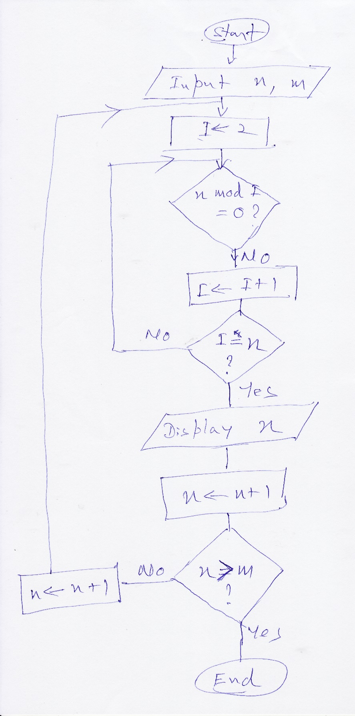

**Question 5**

1. Using a Flow Chart develop an algorithm to find the minimum from a given array of numbers.

(10 Marks)

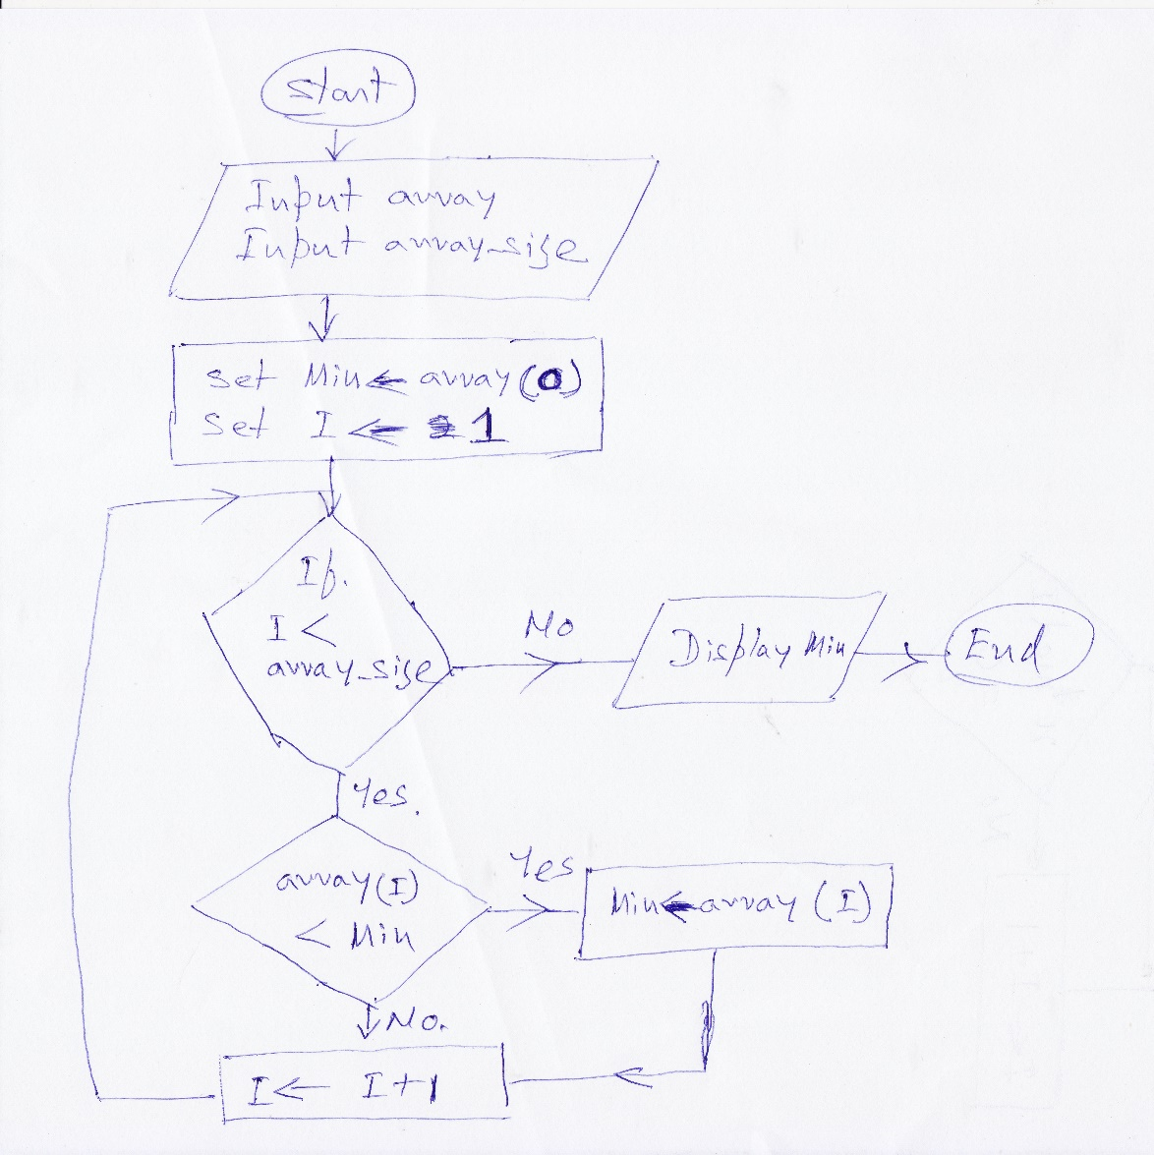

1. Using a pseudo code develop an algorithm to arrange a given array of numbers in ascending order. (Hint – Use two nested loops; outer loop to identify the start of unsorted part of the array and inner loop to find minimum from the unsorted part and bring that/swap to the beginning of the unsorted part)

(10 Marks)

Input array

Input array_size

For I = 0 to array_size -1

Min = array(I)

MinIndex = I

For J = I+1 to array_size -1

IF array(J)<Min

Min = array(J)

MinIndex = J

End IF

J=J+1

End For

array(MinIndex) = array(I)

array(I) = Min

I=I+1

End For

**Question 6**

1. How Internet differs from Web? Explain in brief taking suitable examples.

(6 mark)

Sample Answer:

The Internet is a global, interconnected network of computing devices. The World Wide Web (WWW) is one set of software services running on the Internet. This network supports a wide variety of interactions and communications between its devices. While the Internet, links your computer to other computers around the world, is a way of transporting content. The Web is software that lets you use that content…or contribute your own.

The Web is just one of the ways that information can be disseminated over the Internet. The Internet, not the Web, is also used for email, which relies on SMTP, Usenet news groups, instant messaging and FTP. So the Web is just a portion of the Internet, albeit a large portion, but the two terms are not synonymous and should not be confused.

Marking Scheme:

Defining Internet and Web 2 Mark

Explain the difference 3 Mark

Few examples of web services 1 Mark

1. Define following terms:(9 mark)
2. Intranet
3. Extranet
4. Digital Divide

Sample Answer:

Intranet: An intranet is a private network that is contained within an enterprise. It may consist of many interlinked local area networks and also use leased lines in the wide area network. Typically, an intranet includes connections through one or more gateway computers to the outside Internet. The main purpose of an intranet is to share company information and computing resources among employees

Extranet

An extranet is a private network that uses Internet technology and the public telecommunication system to securely share part of a business's information or operations with suppliers, vendors, partners, customers, or other businesses. An extranet can be viewed as part of a company's intranet that is extended to users outside the company.

Digital Divide

Digital divide is a term that refers to the gap between demographics and regions that have access to modern information and communications technology, and those that don't or have restricted access. This technology can include the telephone, television, personal computers and the Internet.

Marking Scheme:

For each complete definition, offer a maximum of 3 marks (3 X 3 = 9 Mark)

1. Is there an ethical difference in browsing someone else’s computer file and browsing their desk drawer? Justify your answer. (5 mark)

Sample Answer

No! A characteristic common to computer ethics is the difficulty of identifying ethical issues. Many who perform unethical practices with computers don’t see the ethical implications. When caught, their first reaction is, “I didn’t know I did anything wrong. I only looked at the file, I didn’t take it”. People often get access to confidential data and knowledge about individuals' and companies' networks and systems that give them a great deal of power. That power can be abused, either deliberately or inadvertently. Computer ethics should have a strong link to policy or strategy. When an ethical problem is identified, a policy or strategy should be developed to prevent the problem from recurring

The Ten Commandments of Computer Ethics were created in 1992 by the Computer Ethics Institute.

Thou shalt not use a computer to harm other people.

Thou shalt not interfere with other people's computer work.

Thou shalt not snoop around in other people's computer files.

Thou shalt not use a computer to steal.

Thou shalt not use a computer to bear false witness.

Thou shalt not copy or use proprietary software for which you have not paid (without permission).

Thou shalt not use other people's computer resources without authorization or proper compensation.

Thou shalt not appropriate other people's intellectual output.

Thou shalt think about the social consequences of the program you are writing or the system you are designing.

Thou shalt always use a computer in ways that ensure consideration and respect for your fellow humans

Marking Scheme:

For a simple explanation of basic computer ethics, offer a maximum of 5 Mark